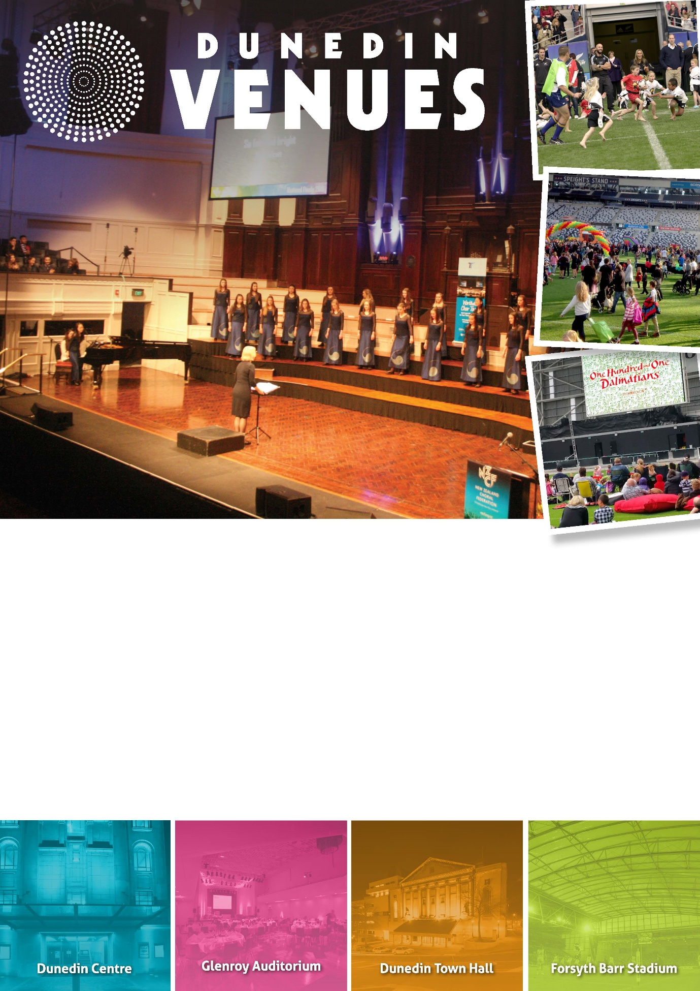

2018 | Dunedin Centre
Community Events Funding Application

Events that do not qualify for funding are listed below. Please check your application against these criteria prior to applying.

- Events/projects run by and for the benefit of commercial or profit-oriented organisations.
- Ticketed events/projects where a cash payment must be paid to attend (koha/donation are exempt).
- Events/projects that have already taken place (no retrospective funding).
- Events/projects that have a political or religious purpose.
- Events/projects whereby an organisation, group of people or a person financially benefits from the Service Level Agreement funding (registered charitable organisations exempt).

Please ensure you have read the Community Events Funding Policy for the Dunedin Centre prior to completing this form.

Completed applications can be submitted through one of the following options:
- Email to info@dunedinvenues.co.nz

- Hand deliver to Dunedin Venues Management Limited reception at Forsyth Barr Stadium (Door J)

- Post to:
130 Anzac Avenue
PO Box 5506, Dunedin 9058

You will be sent an email to confirm your application has been received.

APPLICATION INFORMATION

Funding Applicant Details

Group/Name of Organisation | Click here to enter text.
Contact Name | Click here to enter text.
Alternative Contact Name | Click here to enter text.
Address | Click here to enter text.
Contact Number(s) | Click here to enter text.
Email | Click here to enter text.
Website | Click here to enter text.

Event Organiser Details (if different from Funding Applicant)

Group/Name of Organisation | Click here to enter text.
Contact Name | Click here to enter text.
Address | Click here to enter text.
Contact Number(s) | Click here to enter text.
Email | Click here to enter text.
Website | Click here to enter text.

Status of Applicant/Organisation (tick – certification may be required)

☐ Charitable Trust
☐ Incorporated Society
☐ Limited Liability Company
☐ Not for Profit
☐ Other

Main Purpose of Organisation (tick)

☐ Cultural/Arts
☐ Social/Community/Health
☐ Sporting
☐ Educational
☐ Other (please specify)

Have you requested or been granted other funding for this event (tick)

☐ No
☐ Yes (please specify who you applied to, whether you were allocated funding, and if so, how much) Click here to enter text.

EVENT INFORMATION

Name of Event: Click here to enter text.

Date of Event
First Preference Date: Click here to enter text.
Second Preference Date:Click here to enter text.
Regular event with multiple dates: Click here to enter text.
Please ensure you refer to the Calendar in APPENDIX ONE for available dates before completing.

Type of Funding Requested
The type and level of funding requested is, please tick:
☐ 100% Venue Rental and Event On-Charges (Free Event for all and or donation requested)
☐ 50% Venue Rental and Event On-Charges (Ticketed Event)
Please ensure you refer to Rate Card in APPENDIX TWO.

Pack in/Pack out
If the event requires a pack-in/pack-out day before and/or after the event, please tick:
☐ Pack-in
☐ Pack-out

If your event is to be 50% subsidised (i.e. you are charging an entry fee) please tick your preference:
☐ Guaranteed pack-in/pack-out date which requires 50% rental to be paid for the requested dates
☐ Non-guaranteed pack-in/pack-out date where no venue rental is paid. However this option can be terminated within 4 weeks of the event should a commercial booking for the space be received

Notes
Click here to enter text.

Participants / Spectators:
How many people do you expect at your event?
- Forecast number of spectators Click here to enter text.
- Forecast number of active participants Click here to enter text.

Financial:
Do you plan to charge a fee to participate or attend the event?
☐ No
☐ A Donation will be requested
☐ Yes the event will be ticketed (Please provide price brackets) Click here to enter text.

Spaces Required: (tick)
The Dunedin Centre space/s required for event:
☐ Dunedin Town Hall
☐ Glenroy Auditorium
☐ Fullwood Lounge
☐ Conference Room

Notes:
Click here to enter text.

Event Summary/Objectives:
In a few brief sentences, please describe your event and how it benefits the social, educational, cultural, environmental and or physical wellbeing of the Dunedin community.
Click here to enter text.

Please advise what plans are currently in place for the event (please note, all plans must be made available on request): (tick)

☐ Event Delivery Plan (including back up venue plans)
☐ Business Plan
☐ Marketing Plan
☐ Floorplan layout
☐ Health and Safety Plan
☐ Risk Mitigation Plan
☐ Other

EVENT TYPE

Community Event Hierarchy

The event definitions below determine the level of flexibility applied to individual bookings. This level of flexibility is required as commercial events contracted by Dunedin Venues Management Limited take precedence over some community events.
To assist all users at the time of booking, community events will be classed as Type 2, 3, 4 or 5.
No Type 2 event will be rescheduled or cancelled. This booking is firm.
Types 3, 4 and 5 may be cancelled or rescheduled should a Type 1 booking be accepted by Dunedin Venues Management Limited with no less than 12 weeks’ notice.
Type 4 and 5 may be cancelled or rescheduled should a Type 2 booking be accepted by Dunedin Venues Management Limited with no less than 16 weeks’ notice.
Type 4 event takes precedence over Type 5 should there be two events applying for a single date. Incidental community events should not take precedence over confirmed Type 2, 3, 4 or 5 events.

Event Type

To determine the position in the Community Event hierarchy, event types are defined as follows:

Major Commercial Events (Type 1)

  - An event where a hirer will pay in excess of $10,000 for the hire of the space.
  - An event with a projected attendance of 1,500 paying people.
  - An event which gains National and/or International media exposure.
  - The event requires no community funding.

Examples: Commercial Concerts and Events, Exhibitions and Conferences

Commercial Events (Type 2)

- An event with a projected attendance of approximately 1, 000 paying people.
- An event which gains national media exposure.
- An event which may require subsidized community funding only
- An event which requires a long lead in time due to the booking of production and entertainers

Examples: Concerts, Exhibitions, and Conferences

Large Community Event (Type 3)

- An event where the anticipated attendance is less than 1,000 paying people.
- An event which includes local and national entertainers.
- An event which requires full community funding.
- Significant local media exposure.

Examples: Community Concerts and Fundraising Events

Medium Community Event (Type 4)

- An event where the anticipated attendance is 300 – 1,000.
- An event which requires full community funding.
- Some local media exposure.
Examples: School Productions

Small Community Event (Type 5)

- Events where the anticipated attendance is 25 - 299.
- An event which requires full community funding.
- No media exposure guaranteed.
Examples: Community funding/training seminar

- DECLARATION

Please print, sign, and return this page with your application.

By signing below you agree that all information provided in this application is true and accurate and in accordance with the Dunedin Venues Management Limited Community Events Funding Policy 2018.

I/We Click here to enter text.
Full Name

Click here to enter text.
Address

have formally applied for funding under the Dunedin Centre Community Event Fund and confirm and warrant that to my/our knowledge the details set out in the application are true and correct in all respects.

Click here to enter text.
Signature Date

- CONSIDERATION OF APPLICATIONS
- No late applications will be accepted.
- The application process, from the deadline until notification, takes a maximum of eight weeks.
- Once confirmation is received, applicants should enter their event on the Dunedin City Events Calendar at www.dunedin.govt.nz/events/tell-us-about-an-event/tell-us-about-an-event.
- Applicants should endeavour to submit full and complete applications. Should an attachment be left out, the incomplete application will be returned to the applicant who has one week to return the amended application.

APPENDIX 1
Dates Available 1st July 2018 – 31st December 2018

Jul - 18 |  |  |  |  |  |  |  | Aug - 18 |  |  |  |  |  |  |  | Town Hall Booked
S | M | T | W | T | F | S |  | S | M | T | W | T | F | S |  | Glenroy Booked
1 | 2 | 3 | 4 | 5 | 6 | 7 |  |  |  |  | 1 | 2 | 3 | 4 |  | Town Hall & Glenroy Booked
8 | 9 | 10 | 11 | 12 | 13 | 14 |  | 5 | 6 | 7 | 8 | 9 | 10 | 11
15 | 16 | 17 | 18 | 19 | 20 | 21 |  | 12 | 13 | 14 | 15 | 16 | 17 | 18
22 | 23 | 24 | 25 | 26 | 27 | 28 |  | 19 | 20 | 21 | 22 | 23 | 24 | 25
29 | 30 | 31 |  |  |  |  |  | 26 | 27 | 28 | 29 | 30 | 31
Sep - 18 |  |  |  |  |  |  |  | Oct - 18
S | M | T | W | T | F | S |  | S | M | T | W | T | F | S
 |  |  |  |  |  | 1 |  |  | 1 | 2 | 3 | 4 | 5 | 6
2 | 3 | 4 | 5 | 6 | 7 | 8 |  | 7 | 8 | 9 | 10 | 11 | 12 | 13
9 | 10 | 11 | 12 | 13 | 14 | 15 |  | 14 | 15 | 16 | 17 | 18 | 19 | 20
16 | 17 | 18 | 19 | 20 | 21 | 22 |  | 21 | 22 | 23 | 24 | 25 | 26 | 27
23 | 24 | 25 | 26 | 27 | 28 | 29 |  | 28 | 29 | 30 | 31
20
Nov - 18 |  |  |  |  |  |  |  | Dec - 18
S | M | T | W | T | F | S |  | S | M | T | W | T | F | S
 |  |  |  | 1 | 2 | 3 |  |  |  |  |  |  |  | 1
4 | 5 | 6 | 7 | 8 | 9 | 10 |  | 2 | 3 | 4 | 5 | 6 | 7 | 8
11 | 12 | 13 | 14 | 15 | 16 | 17 |  | 9 | 10 | 11 | 12 | 13 | 14 | 15
18 | 19 | 20 | 21 | 22 | 23 | 24 |  | 16 | 17 | 18 | 19 | 20 | 21 | 22
25 | 26 | 27 | 28 | 29 | 30 |  |  | 23 | 24 | 25 | 26 | 27 | 28 | 29
 |  |  |  |  |  |  |  | 30 | 31

APPENDIX 2

The following Venue Rental Charge and Event On-Charge costs are fixed;
Venue Rental and Event On-Charges – an explanation:
Below are the costs for venue rental and additional event on-charge allowance.
For non-ticketed/free events you can apply for 100% venue rental and 100% additional event on-charge allowance. Funding allocation will be at the Commercial Rate.
For ticketed events you can apply for 50% venue rental and additional 50% event on-charge allowance. Funding allocation will be at the Ticketed Event Subsidy/Discount Rate.

Dunedin Town Hall

Item | Commercial Rate | Ticketed Event Subsidy/Discount
Town Hall Rental Per day/Event | $4000 | $2000
Event On-charge Allowance | $2000 | $1000

Glenroy Auditorium

Item | Commercial Rate | Ticketed Event Subsidy/Deduction
Glenroy rental per day/event | $2500 | $1250
Event On-charge Allowance | $1500 | $750

Fullwood Room

Item | Commercial Rate | Ticketed Event Subsidy/Deduction
Fullwood rental per day/event | $1600 | $750
Event On-charge Allowance | $800 | $400

Conference Room

Item | Commercial Rate | Ticketed Event Subsidy/Deduction
Conference Room rental per day/event | $400 | $200
Event On-charge Allowance | $300 | $150

Event On-Charges
Event on-charges consist of the following:
- Security and Ushers (As determined by the Dunedin Venues Event Delivery Manager)
- Cleaning
- Stage extension out and in ($300 + GST per row of stage extension built)
- In house audio and visual equipment (no operator)
- Organ ($300 + GST)

The Dunedin Centre is equipped with basic in house audio and visual technology. The following items are included as part of the rental:
Dunedin Town Hall:
- Standard Stage wash lighting (no operator)
- Basic audio rigged (no operator)

Glenroy Auditorium:
- Standard Stage wash lighting (no operator)
- Basic audio rigged (no operator)

Fullwood Room:
- Basic internal audio system (no operator)
- Visual projector

Conference Room:
- Basic internal audio system (no operator)
- Visual projector

PLEASE NOTE: Example of event on-charges that may NOT be covered by the event on-charge allowance (these costs will be discussed with hirer on a case-by-case basis):
- Piano and Piano Tune
- Stage Ramp/Loading Ramp Usage
- Special lighting onto stage extension and/or full choir risers

